Mitchell Fontaine
CS-660
03/13/2026
6-1 Assignment: Concurrent Memory Modeling
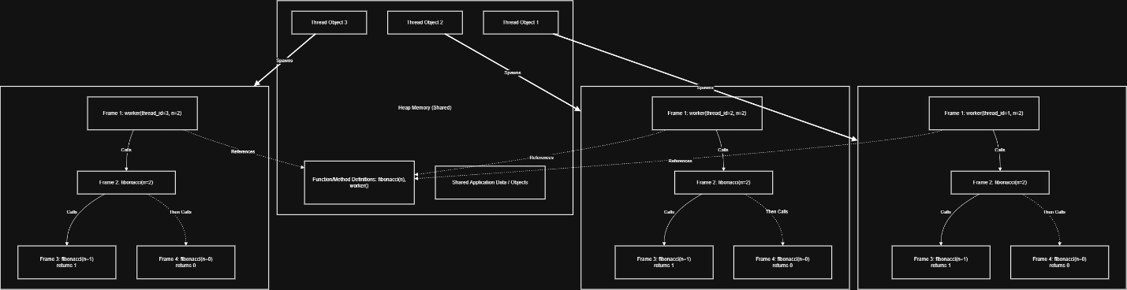
In the design and execution of robust multithreaded applications, particularly those deployed in enterprise or defense-critical environments, the runtime environment divides memory into two primary regions: the shared heap and private thread stacks. The heap serves as the central, global repository for all dynamically allocated objects, data structures, and class definitions during a program’s lifecycle (IBM, 2021). In the context of a multithreaded recursive algorithm, such as calculating the Fibonacci sequence, the heap stores the overarching thread objects, the underlying method definitions, and any shared application data designed to be accessible across multiple concurrent threads. Because the heap is globally accessible, it allows threads to communicate and share state efficiently. However, it also becomes the primary vector for concurrency conflicts. Conversely, the stack is a localized memory region dedicated exclusively to the execution flow of an individual thread. Every time a new thread is spawned by the operating system, it is allocated its own private, isolated stack to manage its operations (Microsoft, 2023). As the thread executes and invokes functions, the stack grows dynamically. Whenever a method is called, a new activation record, commonly referred to as a stack frame, is pushed onto the top of that thread’s stack. This frame is strictly responsible for maintaining the method’s local variables, parameters, and the return memory address required to pass the computed value back to the calling function. Once a specific method completes execution, its corresponding stack frame is popped off, freeing that segment of memory. Because stacks are thread-local, data contained within a stack frame is inherently thread-safe and isolated from the rest of the application (IBM, 2021).
While stack isolation provides inherent thread safety for local variables, the physical memory allocated to a thread stack is finite and strictly limited by the operating system architecture (Microsoft, 2023). Consequently, constraining stack growth is an absolute necessity in secure software engineering, particularly when implementing recursive algorithms. In a recursive Fibonacci function, every single recursive call demands the allocation of an entirely new stack frame. If the function attempts to calculate a deeply nested value without strict base-case constraints or iterative optimization, the stack will grow downward continuously until it exhausts its allocated bounds. When this local memory is depleted, the runtime environment throws a fatal error, immediately terminating the thread and potentially causing the entire application process to crash. Beyond standard debugging concerns, unconstrained stack growth represents a significant operational vulnerability. In production environments, particularly Security Operations Centers monitoring network-facing applications, unbounded recursion can be deliberately exploited by malicious actors to trigger Denial of Service conditions by intentionally exhausting memory resources (Microsoft, 2023). By feeding anomalous data inputs that force a system to evaluate overly deep recursive paths, attackers can intentionally exhaust stack memory and cause critical services to fail. Therefore, developers must constrain stack growth through strict input validation, enforcing maximum recursion depths, or refactoring algorithms to utilize iterative logic, thereby ensuring system resilience and memory safety.
While an unoptimized recursive Fibonacci algorithm operates entirely within private thread stacks and avoids shared state, real-world implementations require optimization to reduce exponential time complexity. Developers usually employ memoization, a caching technique that introduces a shared data structure on the heap to remember previously computed values. However, introducing this shared memory state across multiple threads instantly creates a severe concurrency risk known as a race condition (Oracle, 2024). A race condition manifests when two or more threads attempt to access, read, and modify the exact same memory location on the heap simultaneously without adequate coordination. Because thread execution scheduling is managed unpredictably by the operating system, the exact sequence of reads and writes is non-deterministic (Microsoft, 2023). For example, Thread A might check the shared cache to see if a specific Fibonacci value has been computed. Simultaneously, Thread B might be actively writing the result to that exact memory address. If Thread A reads the memory block while Thread B is only halfway through its write operation, Thread A will retrieve corrupted, partial data. This compromises data integrity, leading to silent computational errors, memory corruption, and highly unpredictable software defects that are notoriously difficult to trace during routine testing and incident response.
To eliminate the risks posed by race conditions and ensure thread safety, we must actively manage how concurrent threads interact with the shared heap by utilizing established synchronization techniques. Synchronization essentially forces a multithreaded application to process critical, shared operations sequentially rather than simultaneously (Oracle, 2024). The most fundamental approach to synchronization is the use of mutual exclusion locks (mutexes). By wrapping the cache-accessing logic within a synchronized block or utilizing a lock object, the developer designates it as a critical section. When a thread reaches this section, it must acquire a unique monitor lock associated with that shared object. While the thread holds this lock, all other threads attempting to access the cache are placed into a blocked state, forced to wait their turn (Oracle, 2024). Once the initial thread completes its read or write operation and exits the block, the lock is released, allowing the next scheduled thread to proceed safely. Alternatively, modern software development usually relies on built-in, thread-safe data structures, such as concurrent hash maps. These advanced structures abstract the locking mechanisms away from us, utilizing highly optimized, granular locking that secures individual segments of the data rather than blocking the entire object (Oracle, 2024). This ensures strict memory safety and eradicates the risk of data corruption, maintaining a much higher level of parallel performance and throughput for secure, scalable systems.
References
IBM. (2021). Java memory management. Ibm.com. https://www.ibm.com/support/pages/understanding-java-memory-management
Microsoft. (2023). Processes and Threads - Win32 apps. Learn.microsoft.com. https://learn.microsoft.com/en-us/windows/win32/procthread/processes-and-threads
Oracle. (2024). Lesson: Concurrency. Docs.oracle.com. https://docs.oracle.com/javase/tutorial/essential/concurrency/

